
Home - Klaus Union
ISO Sealless Pump (Magnetic Drive Pump)
SLM NV
Centrifugal Pump with Magnet Drive based on DIN EN ISO 2858 / 15783
- Flow Rate: max. 3.500 m³/h
- Delivery Head: max. 220 m L.C.
- Temperature Range: -200 °C to +550 °C
- Pressure Rating: max. PN 400
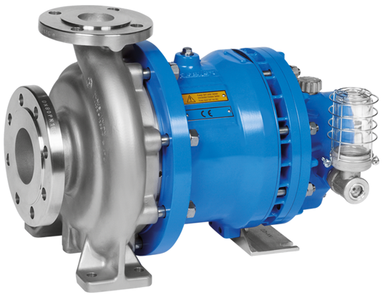

SLM AP
Centrifugal Pump with Magnet Drive acc. API 685
- Flow Rate: max. 3.500 m³/h
- Delivery Head: max. 220 m L.C.
- Temperature Range: -200 °C to +550 °C
- Pressure Rating: max. PN 400
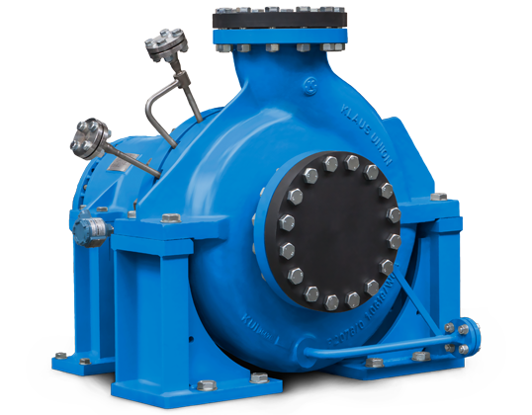

SLM GV
Multi-Stage Centrifugal Pump with Magnet Drive based on DIN EN ISO 15783 / API 685
- Flow Rate: max. 300 m³/h
- Delivery Head: max. 2.200 m L.C.
- Temperature Range: -120 °C to +350 °C
- Pressure Rating: max. PN 250

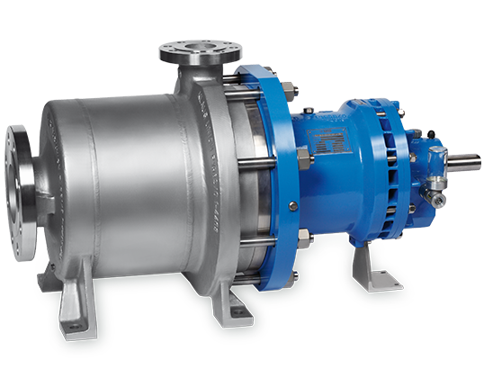

SLM SV
Multi-Stage Side Channel Pump with Magnet Drive based on DIN EN ISO 15783
- Flow Rate: max. 42 m³/h
- Delivery Head: max. 470 m L.C.
- Temperature Range: -120°C to +250 °C
- Pressure Rating: max. PN 400

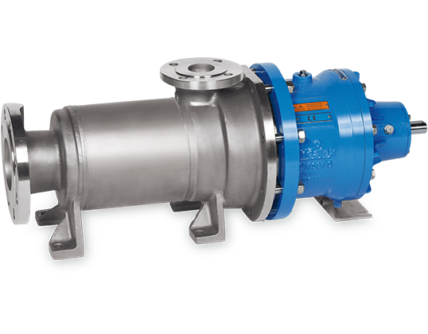

SLM NVT
Submerged Pump with Magnet Drive based on DIN EN ISO 2858 / DIN EN ISO 15783
- Flow Rate: max. 3.500 m³/h
- Delivery Head: max. 220 m L.C.
- Temperature Range: -40 °C to +200 °C
- Pressure Rating: max. PN 63
- Submerging Depth: max. 6.000 mm

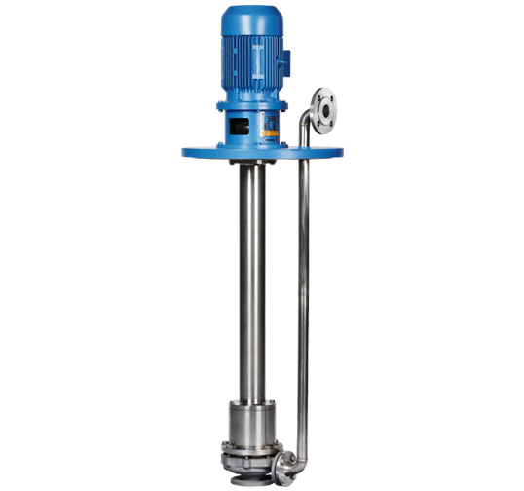

NOV
Centrifugal Pump with Mechanical Seal acc. to DIN EN ISO 2858 / 5199
- Flow Rate: max. 3.500 m³/h
- Delivery Head: max. 220 m L.C.
- Temperature Range: -120 °C to +550 °C
- Pressure Rating: max. PN 400

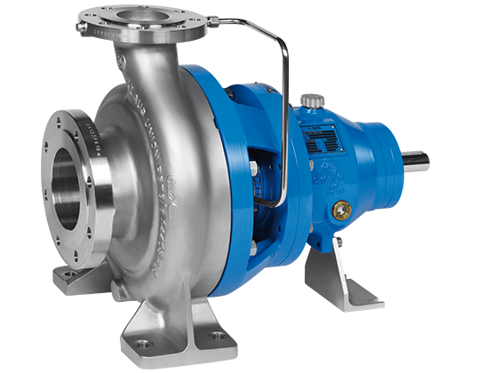

SLM DSP-2C
Single Volute Twin Screw Pump with Magnet Drive acc. to API 676
- Flow Rate: max. 1.800 m³/h
- Differential Pressure: max. 40 bar
- Temperature Range: -120 °C to +400 °C
- Pressure Rating: max. PN 400
- Viscosity: max. 100.000 mm²/s (cSt)

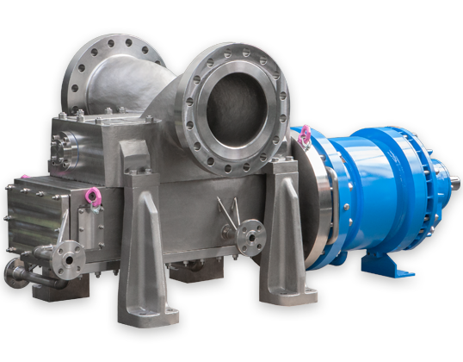

..\PV VENTS.pdf

